|  |  |  |  |
| --- | --- | --- | --- |
| **CS102** | **Fall 2017/2018** | Project Group | 23 |
| Instructor: | **Uğur Güdükbay** |  |  |
| Assistant: | Ömer Sinan Şahin |  |  |

|  |  |  |
| --- | --- | --- |
| **Criteria** | **TA/Grader** | **Instructor** |
| Presentation |  |  |
|  |  |  |
|  |  |  |
|  |  |  |
| Overall |  |  |

~ Dice Chess ~

Night Watchers

Çağrı Orhan 215031022

Onur Mermer 21600878

**Alshir Soyunjov 215004234**

**Güney Arda Doğan 21604083**

**Fırat Yıldız 21502717**

|  |
| --- |
| Detailed Design Report  ( Version 1 )  24 November 2017 |

# Introduction

We chose a variant of chess as our project which is called “Dice Chess”. In this game, we aim to create a different kind of chess game which combines luck and strategy because classical chess game has been played for thousands of years by huge commanders to develop their ability to strategize. After that it started to be play by people but it can get boring and hard to master. We aim to make chess more enjoyable and interesting specifically for beginners.

In this report we will specify the technical issues about the dice chess, which means we will show the detailed design of our classes methods etc. We will also show our UML and the class hierarchy in this detailed design report.

# Details

## Rules of Dice Chess

The rules of dice chess are as follows: The generic chess rules apply in dice chess. However what changes is what pieces a player can move. Each player starts their turns with a dice roll of two dice. If they get one they can play a pawn. If they get two they can play a knight. Same rule applies as follows: three for bishop, four for rook, five for queen, and six for king. If the player rolls doubles they can play any legal move they wish. You consider your moves for both the pieces you end up getting to play due to the dice roll. Additionally when a player has no legal move with either of the pieces indicated by the dice, they lose that turn. If the player has a legal move they cannot skip their turn[1].

However there are two special moves that can be done in chess that can come across as unclear and as such they will be explained here. If castling is legal in the limitations of normal chess rules a player can castle if they have rolled four, six or doubles. Also, when legal within the chess rules, an en passant capture of a pawn is only possible if the player rolls a one or doubles immediately after their opponent moves their pawn double squares giving the player the opportunity for an en passant capture[1].

Lastly in positions such as a check, a checkmate or a draw the rules are as follows: The game can end by either a checkmate or by the king getting captured except for the unlikely event of a draw. The king can be captured if the player in check cannot capture the checking piece and the checking player’s rolls the needed number to capture the king. In the case of a check, if the checked player does not roll a dice that lets them capture the checking piece or roll six to move their king out-of-the-way they lose their turn. The rules of check, checkmate and draw follows the standard rules of chess[1].

## Classes

Board Class – Class that create a new board for the game with pieces. There is a Locatable Array that holds the pieces’ positions. Getting, removing pieces are handled here.

Locatable interface- It is an interface among pieces. Pieces implement Locatable interface. There are methods that setting and getting positions. Locatable interface has also moveTo method that moves the pieces to desired location.

Dice Class – Each round players have to roll a dice and make their move according to dice. Rolling a dice is handled by Dice class. Each round dice class rolls a dice using the random method.

Time Class – There is a time restriction in chess game. Time class counts the time and helps to display time on screen for players.

Player Class – This class gets player’s name and displays on the screen. Player class also assign “White” or “Black” to players.

Check Class-This is the interface of our classes

King Class- King Class has a special named “Castling” but there are some conditions in order to do castling. “Castling can only occur if there are no pieces standing between the king and the rook.  Neither king nor rook may have moved from its original position. Also, when the king is in check or the path is under attack, castling cannot be done.” [2]

Pawn Class – Pawn class has two significant features. One of them is “Promotion”. “Should a pawn manage to make it all the way to the other end of the board, that pawn must promote to any piece its player chooses other than a king.”[3] Other feature about pawn is En Passant. “A move that allows a pawn that has moved two squares to be captured as though it had only moved one.”[3]

## The UML Diagram

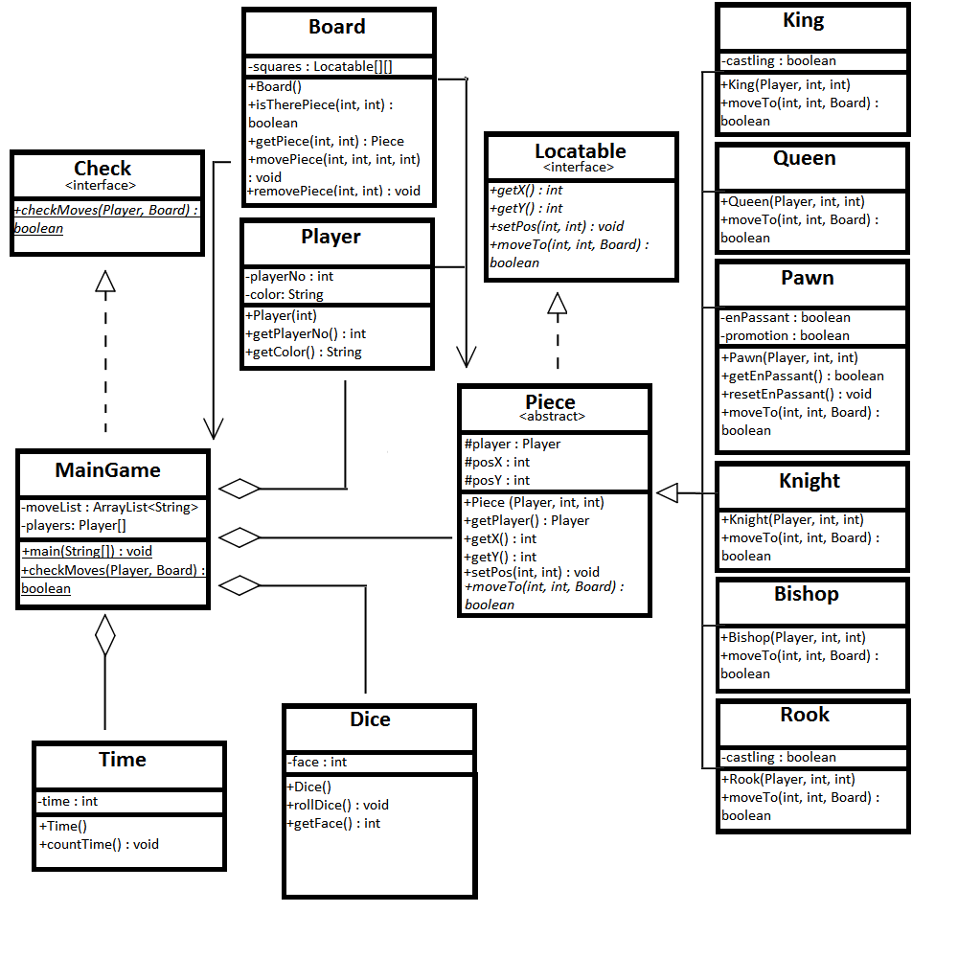

# Summary & Conclusions

We are starting to finally see the glimpses of the end of our project and it looks promising. We finally have something to show for our researches and we hope this project to go smoothly. We will research even further and add even more features if need be. At this state we are focusing on the class hierarchy and their structures. And in the future these will be turned into coding.

# Bibliography

1. Dice Chess. n.d. 22 11 2017 <www.wikiwand.com/en/Dice_chess#/Rules>.
2. Castling. n.d. 22 11 2017 <https://www.chess.com/chessopedia/view/castling>.

3. Scimia, Edward. Special Rules: Castling, Promotion and En Passant. 04 06 2017. 22 11 2017 <https://www.thespruce.com/castling-promotion-and-en-passant-611548>.